

BAŞKENT UNIVERSITY
ELECTRIC & ELECTRONICS ENGINEERING

EEM 214 ~ ELECTRONICS–I
LABORATORY
REPORT

Experiment Name : Oscilloscopes,DMM,Function Generator,Potentiometer
Experiment Number : 1

Student Name : Buğra BAYRAM
Student Number :20193272
Section Number : 02 | Experiment Day: 10 / 3 / 2006

Part_1:

1-)



2-)

Vmax = 0,98V | Vmin = -0,98V
Vavg = 0 V | Vrms = 705,7 mV | Vp-p = 1,96V
Period = 10,08ms |  | Frequency = 99,20Hz

3-) Volts / Div : It doesn’t change the amplitude of the sine wave,it only changes the voltage value per a square,for example if we select 1 volts/div it means every square value is 1 volt on our oscilloscope screen.
Time / Div : It doesn’t change the frequency of the sine wave,it’s function is to change the time scale,for example if its on 2ms time/div it means that every square is 2ms.

Position dial doesn’t add a constant voltage,it changes only the position of our signal.

4-) The plot is given at question 1.(with same scales)

5-) Peak-to-peak voltage can’t read when we give full amplitude at 2 V/div scale.Because there are 8 square along the Y axis on our osilloscope screen,the maximum peak-to-peak voltage can be read is 8x2=16V at this scale(2 V/div),our singal with full amplitude is greater than 16V so we can’t read.

6-) It can’t be seen correctly when we changed the trigger channel 1 to2.Because these changes settings for the 2nd channel.
7-) When we pull the DC offset button on function generator,we can add a DC voltage to our singal.If the scopes coupling setted to AC we can’t see these DC voltage that we added.When we set it to AC,we saw that both AC and DC voltage can be readed.

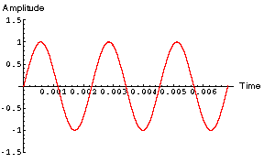 | For example we have a sine wave like this.As shown it’s Vp = 1 V.If we add a DC voltage (for example 1 V) we would be see the same wave until we set the DC couple on the scope.

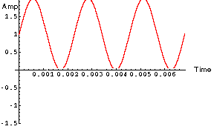 | When we set the DC couple on the scope,we can see both our sine wave and our 1 V DC voltage that added to sine wave.

8-)
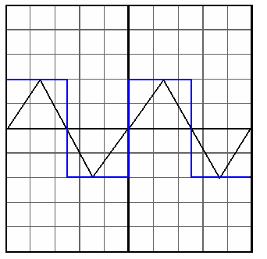
Volts/Div = 1V , Time/Div = 2mS
f = 100Hz
Black signal is triangle,Blue signal is square wave

9-)

We get a constant voltage(5V) with function generator at 5 V/div voltage scale
Part_2:

1-)

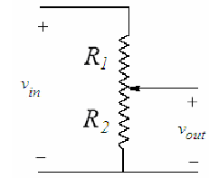 | Vout = [ R2 / (R1 + R2) ] x Vin
2-)
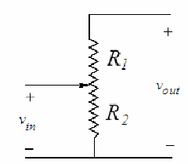 | Vout = [ (R1 + R2) / R2 ] x Vin  We should never use these.  Because (R1 + R2) / R2 is a number greater than 1.So our output voltage should greater than input voltage but it’s not possible.
3-)

 | R1 | R2 | Vout (RL=∞) | Vout (RL=150Ω )
Full clockwise | 4,970 K | 1 Ω | 0,6 mV | 0,6 mV
The center | 2,580 K | 2,512 K | 5 V | 0,6 V
Full counter-clockwise | 1 Ω | 4,888 K | 10 V | 7,2 V

4-) Measurement values of Vout are not same with the expected values.
When full clockwise R2 should 0 so Vout = 0 in theory,but measurements detect a small1 Ω value so we get a small 0,6 mV Vout value.
When potentiometer is centered and full counter-clockwise measured values are nearly same with the expected values.

